Benazir Bhutto Shaheed University
Liyari Karachi


Royal Aurum E-Commerce Platform

Complete Documentation

Batch 14th BSCS 6th A
Project Name | Royal Aurum
Project Type | Full-Stack E-Commerce Application
Domain | Luxury Jewelry
Timeline | 4 Weeks
Status | In Development (MVP Phase)

Submitted To: Miss Ambreen

Table of Contents
S.No | Objective | Page No
1 | Executive Summary | 03
2 | Project Overview | 03
3 | Data Research Phase | 04
4 | Technology Stack | 05
5 | Architecture Overview | 06
6 | Frontend Implementation | 08
7 | Backend Implementation | 13
8 | Database Schema | 19
9 | Features & Functionality | 25

Executive Summary
Royal Aurum is a modern, full-stack e-commerce platform designed to provide a seamless shopping experience for luxury jewelry products. The platform features a responsive React-based frontend with an integrated admin panel for product management, backed by a MySQL database with PHP integration for server-side operations.
The project was completed over a 4-week sprint with the following allocation:
• Week 1 (25%): Data research, data collection, and CSV conversion
• Weeks 2–3 (50%): Frontend development and UI/UX implementation
• Week 4 (25%): Backend development and database integration.
The platform is currently in MVP (Minimum Viable Product) status with core e-commerce functionality implemented. Login page functionality is scheduled for the next development phase. Payment integration has been successfully completed.

Project Overview

Project Objectives
- Create a user-friendly, responsive e-commerce platform for luxury jewelry
- Implement a comprehensive product management system
- Develop an intuitive shopping cart and checkout experience
- Build an admin dashboard for inventory management
- Establish a scalable database architecture for future growth

Product Categories
The platform currently supports the following jewelry categories:
- Rings
- Necklaces
- Bracelets
- Bangles
- Earrings

Target Users
- End Users: Customers seeking luxury jewelry products
- Admin Users: Store administrators and product managers
- Support Users: Customer service representatives (infrastructure ready)

Data Research Phase
This section describes the work performed by the data research team during the project.

Scope of Work
The data research team was responsible for preparing foundational product data for the system. This work was completed before development started to ensure smooth frontend and backend integration.

Tasks Performed
The following tasks were carried out by the data research team:
- Data collection from multiple sources
- Data cleaning and formatting
- Conversion of raw data into structured CSV files
- Product naming standardization
- Product description writing
- Pricing information preparation
- Verification of data accuracy
- Organization of product data by category

Research Output
The final output of this phase included:
- Clean and formatted CSV files
- Structured product names
- Detailed product descriptions
- Verified pricing details

Project Status
Research Activity | Status
Data Collection | Completed
CSV File Conversion | Completed
Product Description Writing | Completed
Pricing Data Preparation | Completed
Data Verification | Completed
This data research phase helped ensure accuracy, consistency, and quality of product information used in the platform.

Technology Stack

Frontend
Framework & Build Tools:
- React 18.x - UI component library
- Vite - Modern build tool and development server
- TypeScript - Type-safe JavaScript development
- shadcn-ui - High-quality React component library
- Tailwind CSS - Utility-first CSS framework
Key Dependencies:
- React Router - Client-side routing and navigation
- State Management - React Hooks (useState, useContext)
- HTTP Client - Fetch API / Axios (for backend communication)
- Icons & UI - shadcn-ui components and Lucide icons
Development Environment:
- Node.js - JavaScript runtime
- npm - Package management
- Git - Version control

Backend
Server & Language:
- PHP 7.4+ - Server-side scripting language
- Local Development Server - PHP built-in server (development only)
Database:
- MySQL 8.0+ - Relational database management system
- phpMyAdmin - Database administration tool (local development)
Tools & Utilities:
- Composer - PHP dependency management (if applicable)
- cURL - HTTP client for API requests

Hosting & Deployment
Current Status: Local development environment
Future Deployment:
- Web hosting platform (to be selected and purchased)
- Apache/Nginx web server
- MySQL database hosting
- SSL/TLS certificate for security

Development Environment Setup
Node.js: v16.x or higher
npm: v8.x or higher
PHP: v7.4 or higher
MySQL: v8.0 or higher
Git: v2.x or higher

Architecture Overview

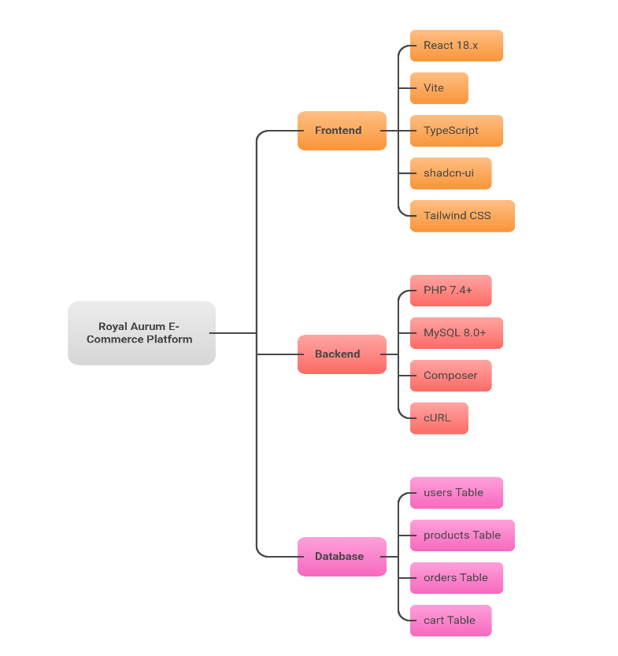

System Architecture Diagram
┌─────────────────────────────────────────────────────────────────┐
│ CLIENT LAYER │
│ ┌──────────────────────────────────────────────────────────┐ │
│ │ React Frontend (SPA) │ │
│ │ ├─ Home Page │ │
│ │ ├─ Categories / Products Listing │ │
│ │ ├─ Search Module │ │
│ │ ├─ Shopping Cart │ │
│ │ ├─ Login / Signup │ │
│ │ └─ Admin Dashboard │ │
│ │ ├─ Add Products │ │
│ │ ├─ Update Products │ │
│ │ ├─ Delete Products │ │
│ │ └─ View Products Overview │ │
│ └──────────────────────────────────────────────────────────┘ │
└─────────────────────────────────────────────────────────────────┘
↓ HTTP/REST API Calls
┌─────────────────────────────────────────────────────────────────┐
│ API LAYER (Middleware) │
│ ┌──────────────────────────────────────────────────────────┐ │
│ │ PHP Backend Services │ │
│ │ ├─ Product Management APIs │ │
│ │ ├─ User Authentication APIs (In Progress) │ │
│ │ ├─ Cart Management APIs │ │
│ │ ├─ Order Processing APIs │ │
│ │ └─ Payment Gateway Integration │ │
│ └──────────────────────────────────────────────────────────┘ │
└─────────────────────────────────────────────────────────────────┘
↓ Database Queries
┌─────────────────────────────────────────────────────────────────┐
│ DATA LAYER │
│ ┌──────────────────────────────────────────────────────────┐ │
│ │ MySQL Database │ │
│ │ ├─ users Table │ │
│ │ ├─ products Table │ │
│ │ ├─ orders Table │ │
│ │ └─ cart Table │ │
│ └──────────────────────────────────────────────────────────┘ │
└─────────────────────────────────────────────────────────────────┘

High-Level Data Flow
- User visits the platform → React frontend loads from Vite server
- User browses products → Frontend fetches product data from PHP backend
- User searches for products → Search query sent to PHP API
- User adds to cart → Cart data stored locally (client-side) or synced to database
- User proceeds to checkout → Order form displayed, data prepared for submission
- Admin manages products → Admin panel calls PHP APIs for CRUD operations
- Database updates → Changes reflected in real-time on the dashboard

Frontend Implementation

Project Structure
frontend/
├── public/
│ └── [Static assets and favicon]
├── src/
│ ├── components/
│ │ ├── Home/
│ │ │ ├── Hero.tsx
│ │ │ ├── FeaturedProducts.tsx
│ │ │ └── ...
│ │ ├── Categories/
│ │ │ ├── ProductListing.tsx
│ │ │ ├── ProductCard.tsx
│ │ │ ├── FilterPanel.tsx
│ │ │ └── ...
│ │ ├── Search/
│ │ │ ├── SearchBar.tsx
│ │ │ └── SearchResults.tsx
│ │ ├── Cart/
│ │ │ ├── CartPage.tsx
│ │ │ ├── CartItem.tsx
│ │ │ └── CartSummary.tsx
│ │ ├── Auth/
│ │ │ ├── Login.tsx
│ │ │ ├── Signup.tsx
│ │ │ └── AuthForm.tsx
│ │ ├── Admin/
│ │ │ ├── Dashboard.tsx
│ │ │ ├── ProductManagement.tsx
│ │ │ ├── AddProduct.tsx
│ │ │ ├── EditProduct.tsx
│ │ │ ├── DeleteProduct.tsx
│ │ │ └── ProductOverview.tsx
│ │ ├── Common/
│ │ │ ├── Header.tsx
│ │ │ ├── Footer.tsx
│ │ │ ├── Navigation.tsx
│ │ │ └── Sidebar.tsx
│ │ └── Shared/
│ │ ├── Button.tsx
│ │ ├── Modal.tsx
│ │ ├── Card.tsx
│ │ └── ...
│ ├── pages/
│ │ ├── Home.tsx
│ │ ├── Categories.tsx
│ │ ├── Search.tsx
│ │ ├── Cart.tsx
│ │ ├── Login.tsx
│ │ ├── Admin.tsx
│ │ ├── OrderReceipt.tsx
│ │ └── ThankYou.tsx
│ ├── hooks/
│ │ ├── useCart.ts
│ │ ├── useProduct.ts
│ │ ├── useSearch.ts
│ │ └── useAuth.ts
│ ├── context/
│ │ ├── CartContext.tsx
│ │ ├── UserContext.tsx
│ │ └── ProductContext.tsx
│ ├── services/
│ │ ├── api.ts
│ │ ├── productService.ts
│ │ ├── cartService.ts
│ │ ├── orderService.ts
│ │ └── authService.ts
│ ├── types/
│ │ ├── product.types.ts
│ │ ├── user.types.ts
│ │ ├── order.types.ts
│ │ └── cart.types.ts
│ ├── styles/
│ │ ├── globals.css
│ │ ├── tailwind.config.js
│ │ └── ...
│ ├── App.tsx
│ └── main.tsx
├── package.json
├── vite.config.ts
├── tsconfig.json
└── tailwind.config.js

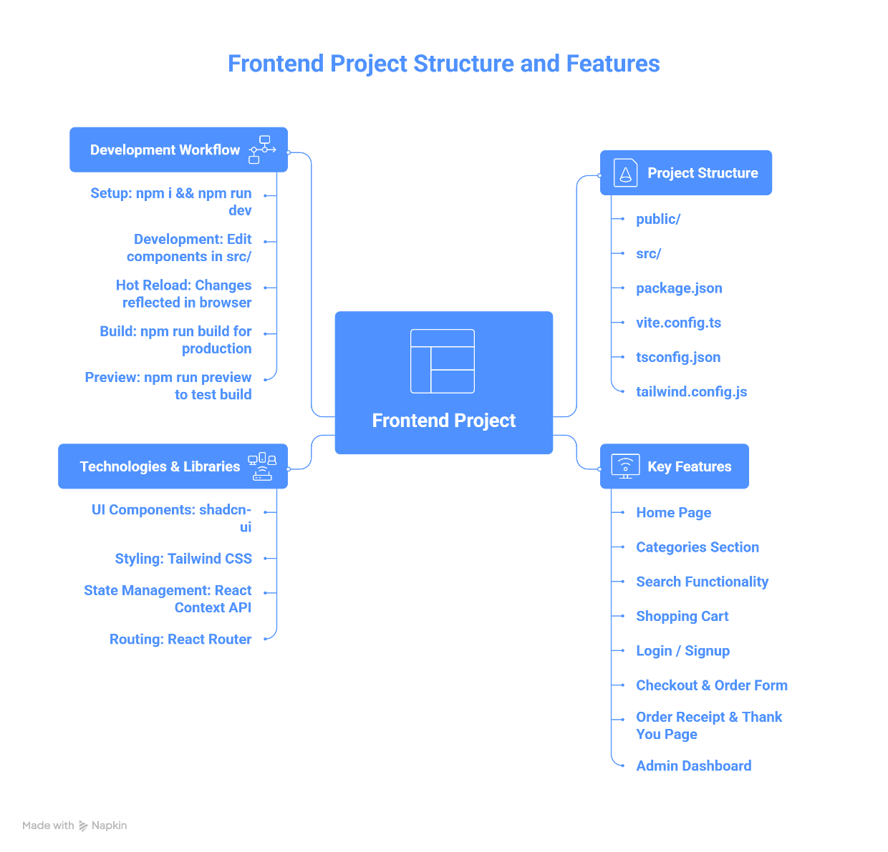

Key Frontend Features

1. Home Page
- Hero section with promotional banner
- Featured products showcase
- Category previews
- Call-to-action buttons
- Responsive design for mobile, tablet, and desktop

2. Categories Section
- Grid layout displaying all products
- Product cards with images, names, prices, and ratings
- Filter by category (Rings, Necklaces, Bracelets, Bangles, Earrings)
- Sort options (price, rating, newest)
- Pagination for large product lists
- Quick add-to-cart functionality

3. Search Functionality
- Real-time search bar on header/navigation
- Search results displayed dynamically
- Filter search results by price range, category, rating
- "No results" handling with suggestions
- Search history (optional enhancement)

4. Shopping Cart
- Display all items added by user
- Show product image, name, price, quantity
- Update quantity with + and - buttons
- Remove item functionality
- Calculate subtotal, tax, and total
- "Continue Shopping" and "Place Order" buttons
- Persistent cart (local storage or database sync)

5. Login / Signup
- Login form with email and password fields
- Signup form with name, email, password, and confirmation
- Form validation with error messages
- "Remember Me" functionality (optional)
- Password reset link (future enhancement)
- Social login integration (future enhancement)

6. Checkout & Order Form
- Multi-step checkout process (optional)
- Customer information form:
  - Full Name
  - Email Address
  - Phone Number
  - Delivery Address
  - Postal Code
  - City
  - State
  - Country
- Payment details form (placeholder for integration)
- Order review before final submission
- Terms and conditions checkbox

7. Order Receipt & Thank You Page
- Order confirmation with order ID
- Thank you message
- Order summary table
- Estimated delivery date
- Download receipt as PDF (future enhancement)
- Order tracking link (future enhancement)

8. Admin Dashboard
- Product overview with statistics
- Add New Product form:
  - Product name, description
  - Price, SKU
  - Category selection
  - Inventory quantity
  - Certificate details (for jewelry)
  - Product images upload
  - Status selection
- Edit Product functionality with pre-filled data
- Delete Product with confirmation dialog
- View all products in table format
- Product search and filter
- Bulk actions (future enhancement)

Frontend Technologies & Libraries
UI Components: shadcn-ui provides pre-built, accessible components
- Buttons, Cards, Forms, Modals, Dropdowns, etc.
Styling: Tailwind CSS utility classes for rapid development
- Responsive design utilities
- Dark mode support (optional)
- Custom color schemes for jewelry brand
State Management: React Context API with Hooks
- CartContext for shopping cart state
- UserContext for authentication state
- ProductContext for product data
- Custom hooks for business logic
Routing: React Router for single-page navigation
- /home - Home page
- /categories - Products listing
- /search - Search results
- /cart - Shopping cart
- /login - Login page
- /signup - Signup page
- /admin - Admin dashboard
- /order-receipt - Order confirmation
- /thank-you - Thank you page

Frontend Development Workflow
- Setup: npm i && npm run dev
- Development: Edit components in src/ folder
- Hot Reload: Changes automatically reflected in browser
- Build: npm run build for production
- Preview: npm run preview to test production build locally

Backend Implementation

Project Structure
backend/
├── config/
│ ├── database.php
│ └── constants.php
├── controllers/
│ ├── ProductController.php
│ ├── UserController.php
│ ├── OrderController.php
│ ├── CartController.php
│ └── AuthController.php
├── models/
│ ├── Product.php
│ ├── User.php
│ ├── Order.php
│ ├── Cart.php
│ └── Database.php
├── routes/
│ └── api.php
├── middleware/
│ ├── Authentication.php
│ ├── Validation.php
│ └── CORSHandler.php
├── utils/
│ ├── Response.php
│ ├── Validator.php
│ └── Logger.php
├── index.php
├── .htaccess
└── [Other configuration files]

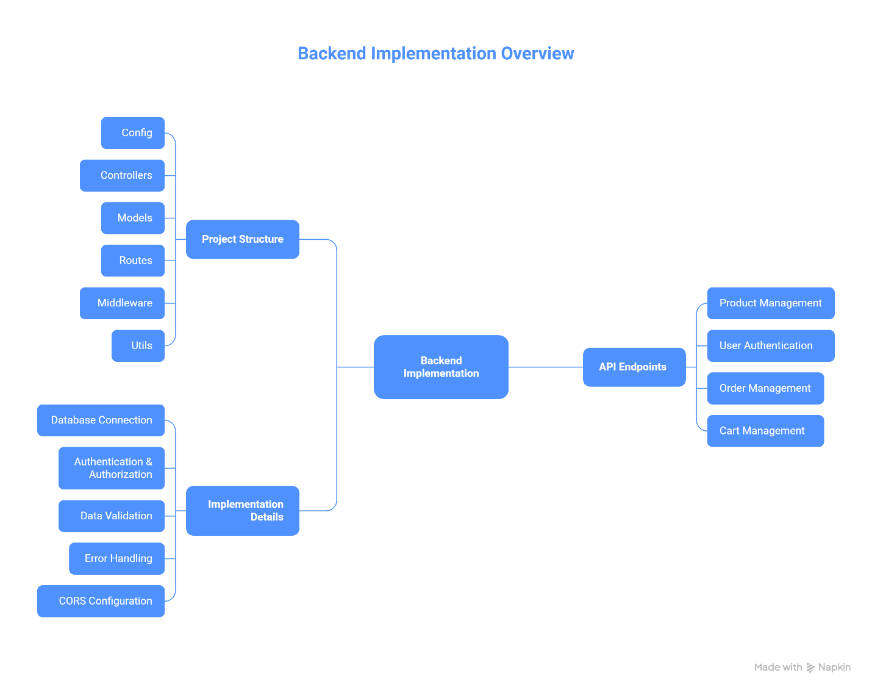

Backend API Endpoints

Product Management APIs
GET /api/products
- Retrieve all products
- Query parameters: page, limit, category, sort, search
- Response: Array of product objects
GET /api/products/{id}
- Retrieve single product details
- Response: Product object with full details
POST /api/products (Admin Only)
- Create new product
- Required fields: name, price, category, sku
- Response: Created product with ID
PUT /api/products/{id} (Admin Only)
- Update existing product
- Required fields: id + fields to update
- Response: Updated product object
DELETE /api/products/{id} (Admin Only)
- Delete product by ID
- Response: Deletion confirmation

User Authentication APIs (In Progress)
POST /api/auth/signup
- User registration
- Required fields: full_name, email, password, phone
- Response: User object + auth token
POST /api/auth/login
- User login
- Required fields: email, password
- Response: User object + auth token
POST /api/auth/logout
- User logout
- Response: Success message
GET /api/users/{id}
- Get user profile information
- Response: User object

Order Management APIs
POST /api/orders
- Create new order
- Required fields: user_id, items_json, total_amount, shipping_address, payment_method
- Response: Order confirmation with order ID
GET /api/orders/{id}
- Retrieve order details
- Response: Complete order information
GET /api/orders/user/{user_id}
- Get all orders for user
- Response: Array of user's orders
PUT /api/orders/{id}
- Update order status (admin)
- Response: Updated order

Cart Management APIs
GET /api/cart/{user_id}
- Retrieve user's cart
- Response: Cart object with items
POST /api/cart/add
- Add product to cart
- Required fields: user_id, product_id, quantity
- Response: Updated cart
PUT /api/cart/update
- Update item quantity in cart
- Required fields: user_id, product_id, quantity
- Response: Updated cart
DELETE /api/cart/remove
- Remove item from cart
- Required fields: user_id, product_id
- Response: Updated cart
DELETE /api/cart/clear/{user_id}
- Clear entire cart
- Response: Confirmation message
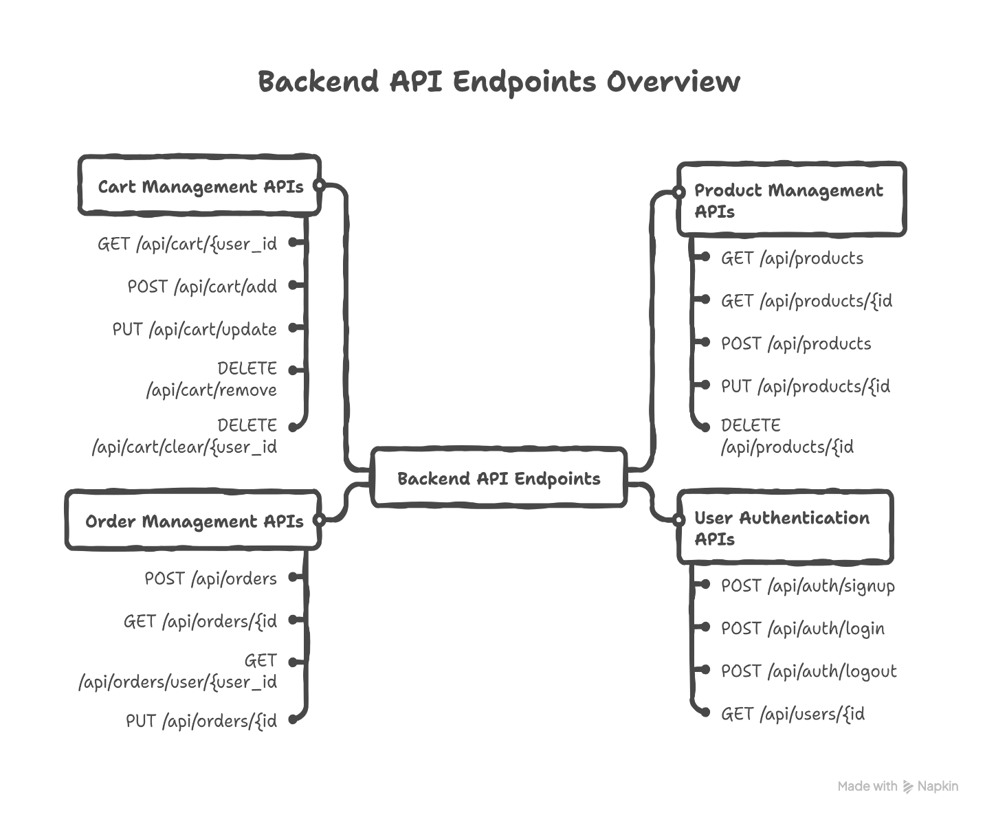

Backend Implementation Details

Database Connection (database.php)
- MySQLi or PDO connection
- Environment-based configuration
- Connection pooling for performance
- Error handling and logging

Authentication & Authorization
- Role-based access control (customer, admin, support)
- Bearer token authentication (to be implemented)
- Password hashing using bcrypt
- Session management (to be implemented)

Data Validation
- Input sanitization to prevent SQL injection
- Type checking for all inputs
- Email validation
- Phone number format validation
- Price and quantity validation

Error Handling
- HTTP status codes (200, 400, 401, 403, 404, 500)
- JSON error responses with messages
- Logging of all errors
- User-friendly error messages

CORS Configuration
- Allow requests from frontend domain
- Handle preflight requests
- Secure cross-origin communication

Backend Development Status
Completed:
- Database schema and table creation
- Product management CRUD operations
- Order creation and management
- Cart operations
- Database integration with PHP
- API endpoint structure
- Payment gateway integration
In Progress:
- Authentication and login functionality
- Session management
- Token-based authentication
- User registration flow
Not Yet Started:
- Email notifications
- Shipping integration
- Advanced error handling

Database Schema

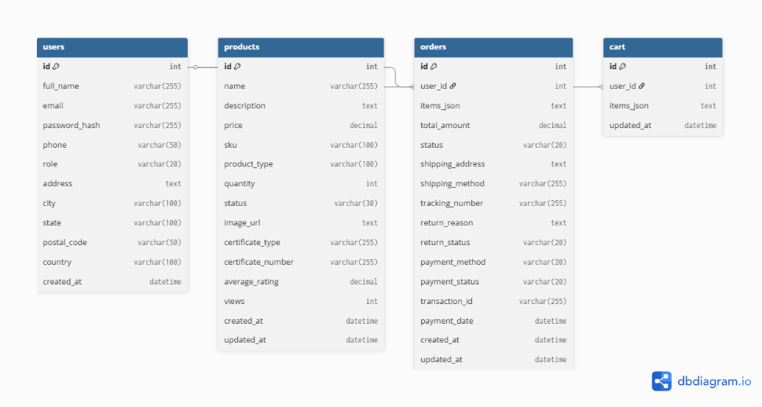

Complete Database Design

1. Users Table
Purpose: Stores all customer and account information
Column | Type | Constraints | Description
id | INT | PK, AI | Unique user identifier
full_name | VARCHAR(255) | NOT NULL | User's full name
email | VARCHAR(255) | UNIQUE, NOT NULL | Login email address
password_hash | VARCHAR(255) | NOT NULL | Encrypted password
phone | VARCHAR(50) |  | Contact telephone number
role | ENUM | DEFAULT 'customer' | User type (customer/admin/support)
address | TEXT |  | Full residential address
city | VARCHAR(100) |  | City of residence
state | VARCHAR(100) |  | State/Province
postal_code | VARCHAR(50) |  | ZIP/Postal code
country | VARCHAR(100) |  | Country
created_at | DATETIME | DEFAULT CURRENT_TIMESTAMP | Account creation timestamp
Relationships:
- One user has many orders
- One user has one cart

2. Products Table
Purpose: Stores all product information, inventory, media, and certification data
Column | Type | Constraints | Description
id | INT | PK, AI | Unique product identifier
name | VARCHAR(255) | NOT NULL | Product name
description | TEXT |  | Detailed product description
price | DECIMAL(10,2) | NOT NULL | Product price in currency
sku | VARCHAR(100) |  | Stock keeping unit identifier
product_type | VARCHAR(100) |  | Category (necklace, ring, earrings, etc.)
quantity | INT | DEFAULT 0 | Current inventory stock level
status | ENUM | DEFAULT 'in-stock' | Status (in-stock/low-stock/out-of-stock)
image_url | TEXT |  | URL to main product image
certificate_type | VARCHAR(255) |  | Jewelry certification type (GIA, etc.)
certificate_number | VARCHAR(255) |  | Certification reference number
average_rating | DECIMAL(3,2) | DEFAULT 0 | Average customer rating (0-5)
views | INT | DEFAULT 0 | Total product page views
created_at | DATETIME | DEFAULT CURRENT_TIMESTAMP | Product creation timestamp
updated_at | DATETIME | DEFAULT CURRENT_TIMESTAMP ON UPDATE | Last modification timestamp
Relationships:
- Many products referenced in orders (via JSON)
- Many products referenced in carts (via JSON)

3. Orders Table
Purpose: Manages complete order lifecycle from creation through returns
Column | Type | Constraints | Description
id | INT | PK, AI | Unique order identifier
user_id | INT | FK → users(id) | Customer who placed order
items_json | JSON | NOT NULL | Array of purchased items with product_id, qty, price
total_amount | DECIMAL(10,2) | NOT NULL | Total order value
status | ENUM | DEFAULT 'pending' | Order state (pending/paid/shipped/delivered/cancelled/returned)
shipping_address | TEXT |  | Delivery address for order
shipping_method | VARCHAR(255) |  | Shipping type (standard/express/etc)
tracking_number | VARCHAR(255) |  | Courier tracking number
return_reason | TEXT |  | Reason for return request
return_status | ENUM |  | Return progress (requested/approved/rejected/refunded)
payment_method | ENUM | NOT NULL | Payment type (card/cod/paypal/giftcard)
payment_status | ENUM | DEFAULT 'pending' | Payment state (pending/completed/failed/refunded)
transaction_id | VARCHAR(255) |  | Payment gateway transaction ID
payment_date | DATETIME |  | When payment was processed
created_at | DATETIME | DEFAULT CURRENT_TIMESTAMP | Order creation timestamp
updated_at | DATETIME | DEFAULT CURRENT_TIMESTAMP ON UPDATE | Last update timestamp
Relationships:
- Many orders belong to one user (user_id FK)
- Each order contains multiple products (items_json)
JSON Structure Example:
[
{
"product_id": 5,
"name": "Gold Diamond Ring",
"quantity": 1,
"price": 5999.99,
"sku": "RING-001"
},
{
"product_id": 12,
"name": "Pearl Necklace",
"quantity": 2,
"price": 1299.99,
"sku": "NECK-002"
}
]

4. Cart Table
Purpose: Stores temporary shopping cart items before checkout
Column | Type | Constraints | Description
id | INT | PK, AI | Unique cart identifier
user_id | INT | UNIQUE, FK → users(id) | User who owns cart
items_json | JSON |  | Array of cart items with product_id, quantity
updated_at | DATETIME | DEFAULT CURRENT_TIMESTAMP ON UPDATE | Last modification time
Relationships:
- One cart belongs to one user (one-to-one)
- Each cart contains multiple products (items_json)
JSON Structure Example:
[
{
"product_id": 5,
"quantity": 1,
"name": "Gold Diamond Ring",
"price": 5999.99
},
{
"product_id": 12,
"quantity": 1,
"name": "Pearl Necklace",
"price": 1299.99
}
]

Entity-Relationship Diagram (Conceptual)
┌────────────────────┐
│ USERS │
├────────────────────┤
│ id (PK) │
│ full_name │
│ email (UNIQUE) │
│ password_hash │
│ phone │
│ role │
│ address │
│ city │
│ state │
│ postal_code │
│ country │
│ created_at │
└────────────────────┘
▲ 1
│
│ N
│
┌─────────────────────┐
│ ORDERS │
├─────────────────────┤
│ id (PK) │
│ user_id (FK) │◄────┐
│ items_json │ │
│ total_amount │ │
│ status │ │
│ shipping_address │ │
│ shipping_method │ │
│ tracking_number │ │
│ return_reason │ │
│ return_status │ │
│ payment_method │ │
│ payment_status │ │
│ transaction_id │ │
│ payment_date │ │
│ created_at │ │
│ updated_at │ │
└─────────────────────┘ │
│
References
PRODUCTS
(via JSON)

┌────────────────────┐
│ PRODUCTS │
├────────────────────┤
│ id (PK) │
│ name │
│ description │
│ price │
│ sku │
│ product_type │
│ quantity │
│ status │
│ image_url │
│ certificate_type │
│ certificate_number │
│ average_rating │
│ views │
│ created_at │
│ updated_at │
└────────────────────┘
▲ 1
│
│ M (via JSON)
│
┌────────────────┐
│ CART │
├────────────────┤
│ id (PK) │
│ user_id (FK) │
│ items_json │
│ updated_at │
└────────────────┘
▲ 1
│
│ 1
│
└─ USERS (id)

Database Relationships Summary
Relationship | Type | Description
Users → Orders | 1:N | One user has many orders
Users → Cart | 1:1 | One user has one cart
Orders → Products | M:N | Many orders contain many products (via items_json)
Cart → Products | M:N | Many cart items refer to many products (via items_json)

Features & Functionality

Currently Implemented Features

1. User Interface & Experience
- Responsive design for desktop, tablet, and mobile devices
- Modern UI with Tailwind CSS styling
- shadcn-ui component library for consistency
- Intuitive navigation and user flow
- Category-based product browsing
- Fast page loads with Vite build tool

2. Product Management
- Display all products with images, names, and prices
- Filter products by category
- Sort products by price, rating, newest
- Real-time search functionality
- Product detail pages with specifications
- Jewelry certification display
- Product ratings and reviews display (backend ready)

3. Shopping Cart
- Add products to cart
- Update item quantities
- Remove items from cart
- Calculate subtotal, tax, and total
- Clear entire cart
- Persistent cart (local storage)
- Database sync (in progress)

4. Checkout & Orders
- Multi-field checkout form
- Collect customer information:
  - Name, email, phone
  - Complete address with postal code
  - City, state, country
- Order summary display
- Order confirmation page
- Thank you message
- Order database storage
- Order receipt PDF (planned)
- Order tracking (planned)

5. Admin Panel
- Dashboard with product overview
- Add new products
- Edit existing products
- Delete products
- View all products in table format
- Real-time database updates
- Product search and filtering

6. Home Page
- Hero section with banners
- Featured products showcase
- Category previews
- Call-to-action buttons
- Responsive design

7. About Page
- Company information
- Mission and values
- Contact information

8. Technical Features
- Type-safe development with TypeScript
- Component-based architecture
- API integration ready
- Context-based state management
- Custom hooks for reusable logic
- Error handling and validation

Features In Progress

1. Authentication & Login
- User registration/signup
- User login with credentials
- Password validation and hashing
- Session management
- Remember me functionality
- Role-based access control
Status: Backend infrastructure ready, frontend integration pending

2. Payment Integration
- Secure payment processing
- Multiple payment methods (card, COD, digital wallets)
- Payment status tracking
- Transaction logging
Status: Fully implemented and successfully integrated.

Planned Features (Future Releases)
- User Accounts & Profiles
  - Account management
  - Order history
  - Saved addresses
  - Wishlist functionality
  - Account preferences
- Advanced Search & Filtering
  - Multi-criteria filtering
  - Price range slider
  - Rating filter
  - Size/specification filters
  - Search suggestions
- Product Reviews & Ratings
  - User review submission
  - Photo upload with reviews
  - Rating system (1-5 stars)
  - Helpful votes
  - Review moderation (admin)
- Inventory Management
  - Stock level alerts
  - Automated reorder points
  - Inventory forecasting
  - Bulk import/export
- Order Management
  - Order tracking
  - Shipment notifications
  - Return management
  - Refund processing
  - Order history archive
- Email Notifications
  - Order confirmation email
  - Shipment tracking emails
  - Return status updates
  - Promotional emails
  - Newsletter subscription
- Analytics & Reporting
  - Sales dashboard
  - Product performance metrics
  - Customer behavior analysis
  - Revenue reports
  - Inventory reports
- Advanced Features
  - Wishlist and favorites
  - Product recommendations
  - Seasonal collections

